Notes: Tener & Tener Idioms (essential skill)

Like Ser and Estar, Tener is an _________________verb. It means “________________” in English.
Tener conjugations
Singular Plural
Yo__tengo_ = I have | Nosotros_tenemos_=we (m) have  Nosotras =we (f) have
Tú__tienes__=You (informal)  have | x
Él = he has  Ella tiene____ =she has  Usted =you  (formal) have  *1 thing | Ellos =They (m) have  Ellas __tienen____ =They (f) have  Ustedes =You (plural) have  ** 2> things

Fill in blanks (la columna a la derecha) w/ the correct conjugation (form) of tener.
Fill in the missing English words (la columna a la izquierda)

1. I have a _____ tomato. Yo_______________un tomate rojo.
2. The cat has an __________. El gato____________un aguacate.
3. Juan and I have ______ carrots. Juan y yo___________unas zanahorias.
4. Marisa _____Ana _______cereal. Marisa y Ana____________cereal.
5. Do you have _____ tiger? ¿____________tú un tigre?
6. We have a _________dog. Nosotros______________un perro.
7. Do _______ have some cows? ¿_____________ ellos unas vacas?
8. Do ___________ have bacon? Ustedes___________tocino.
9. The ________ has hot soup. La mosca___________sopa caliente.
10. Do the penguins have a __________? ¿__________________los pingüinos una cuchara?

Tener Idioms

1. An idiom is_________________________________________________________
2. When Tener is used in certain phrases, it does not translate as “to have” in English.
Tener # años = _____To be #years old (to have # years)
Tener sed = ____________________ (to have thirst)
Tener hambre =_____________________ (to have hunger)
Tener frío =_____________________ (to have cold)
Tener calor =_____________________ (to have heat)
Tener prisa =_____________________ (to have hurry)
Tener cuidado =_____________________(to have care)
Tener razón =_____________________ (to have reason)
Tener miedo =_____________________(to have fear)
IV. Practice with Tener Idioms
Example: ¡El venado tiene prisa porque hay unos leones!
The deer is in a hurry because there are some lions!

1. I am not hungry. Yo no ____________hambre.
2. Are you thirsty? ¿________________ tú sed?
3. The dog is very hot. El perro_____________mucho calor.
4. The bears are not cold. Los osos no ____________frío.
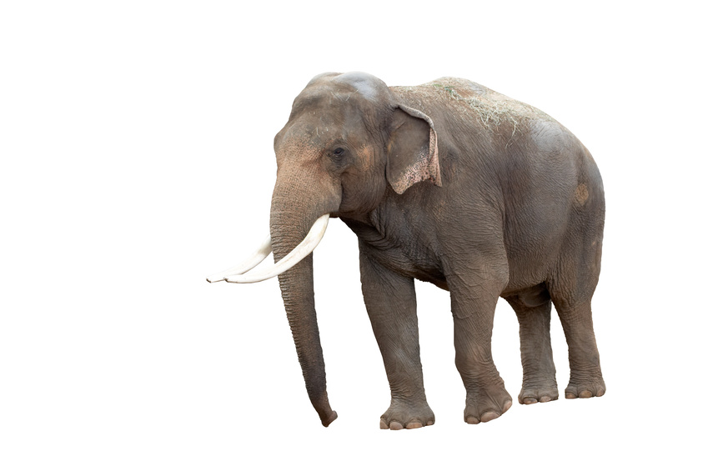
5. Carmen and I are 12 years old. Carmen y yo_________ doce años.
6. Carlos is in a big hurry. Carlos_____________mucha prisa.
7. Are you afraid? ¿______________tú miedo?
8. In Africa, the elephants are hot. En África, los elefantes___________ calor.

9. At noon, we are very hungry. Al mediodía, nosotros __________mucha hambre.

10. The penguins are not thirsty. Los pingüinos no_____________sed.
11. Is the cow five years old? ¿___________ la vaca cinco años?

12. I am careful. Yo__________________cuidado.
13. We are not in a hurry. Nosotros no_________________prisa.

